Teacher Notes for
“Ecosystem Services – How Some Wild Animals Protect Human Health”

In this minds-on activity, students are introduced to the concept of ecosystem services. Then, students analyze two examples that illustrate how some wild animals protect human health. First, students learn how the widespread use of a veterinary drug poisoned vultures in India. This increased the populations of rats and feral dogs, which caused an increase in human mortality due to rabies and other infections. Second, students analyze how a human-spread fungal infection killed millions of North American hibernating bats. The loss of insect-eating bats caused farmers to increase their use of insecticides, which led to increased infant mortality.

I have prepared two versions of the Student Handout. The more complete version of the Student Handout will be suitable for most high school students; the simpler version will be suitable for most middle school students. In these Teacher Notes, the question numbers refer to the more complete Student Handout (simpler Student Handout). I have also provided a PowerPoint so you can show color versions of the Student Handout figures.

Learning Goals
In accord with the Next Generation Science Standards:
- Students will gain understanding of the Disciplinary Core Idea, LS2.C: Ecosystem Dynamics. “Extreme fluctuations in conditions or the size of any population, however, can challenge the functioning of ecosystems in terms of resources and habitat availability. Moreover, anthropogenic changes (induced by human activity) in the environment – … – can disrupt an ecosystem and threaten the survival of some species.”
- Students will engage in the Scientific Practice, Constructing Explanations. “Apply scientific ideas, principles and/or evidence to provide an explanation of phenomena…”
- This activity provides the opportunity to discuss the Crosscutting Concept, Stability and change: “Students understand that much of science deals with constructing explanations of how things change and how they remain stable.”
- This activity will help students to meet these Performance Expectations:
  - HS-LS2-6. “Evaluate the claims, evidence and reasoning that … changing conditions may result in a new ecosystem.”
  - MS-LS2-4. “Construct an argument supported by empirical evidence that changes to physical or biological components of an ecosystem affect populations.”

Instructional Suggestions and Background Information
To maximize student learning and participation, I recommend that you have your students work in pairs to answer each group of related questions. Student learning is increased when students discuss scientific concepts to develop answers to challenging questions. After your students have answered each group of related questions, I recommend that you have a class discussion to probe student thinking and help students develop a sound understanding of the concepts and information covered.

You may want to revise the Word document to prepare a version of the Student Handout that will be more suitable for your students. If you use the Word document, please check the format by viewing the PDF.

A key is available upon request to Ingrid Waldron (iwaldron@upenn.edu). The following pages provide instructional suggestions and additional background information – some for inclusion in your class discussions and some to provide you with relevant background that may be useful for your understanding and/or for responding to student questions.

Ecosystem services are defined as “the benefits that humans receive from nature”. Ecosystem services include lumber, fish, medicines, and flood control (https://en.wikipedia.org/wiki/Ecosystem_service). Other examples include:
- Plant pollinators include wild bees, butterflies, and thousands of other species of wild invertebrates, as well as more than a thousand species of wild vertebrates. Coffee and tomatoes are examples of agricultural crops that are pollinated by wild insects (https://pmc.ncbi.nlm.nih.gov/articles/PMC1702377/).
- Wetlands purify water by several processes. Plants take up nutrients, microbes break down chemical pollutants, and sediment is reduced by the slowdown of flow through wetlands.
- Scavengers and decomposers break down organic molecules in dead organic matter to smaller molecules that plants can use. Photosynthesis uses CO₂ and H₂O produces organic molecules and O₂.
- Another ecosystem service is the prevention of disease; this activity analyzes two examples. For more examples, see https://epic.uchicago.edu/news/first-the-frogs-died-then-people-got-sick/.

After question 1 (1), students are instructed to watch a ~5-minute video “Vultures: the acid-puking, plague-busting heroes of the ecosystem” (https://www.youtube.com/watch?v=1WIUuGCIfcc). This video provides a general introduction to vultures. Vultures have very acid stomachs with a pH between 0 and 1, which is acid enough to kill most germs that are present in a decaying carcass (pH is proportional to minus the log of the concentration of hydrogen ions; https://www.todayifoundout.com/index.php/2014/10/dont-vultures-get-sick-eating-dead-things-cant/). This very acid stomach leads to a reduced risk of spreading disease, which is an important advantage of vultures as scavengers, compared to rats and dogs.

After question 2 (2), students are instructed to watch the ~4-minute video, “How a die-off of vultures cost a country billions” (https://www.youtube.com/watch?v=OwYPzeD3TJc). This video mentions renal (kidney) failure and zoonotic diseases (infections that can spread from nonhuman animals to humans).

The veterinary drug, diclofenac, caused vulture populations in India to decrease by about 90-95%. It will take a long time for vulture populations to recover, since vulture pairs produce one egg per year starting at about age 5.

Pseudogymnoascus destructans (Pd) is a fungal infection of hibernating bats that causes white-nose syndrome (WNS) (see figure at right). In 2006, Pd arrived in North America from Europe, where bats have apparently evolved resistance over the centuries of exposure to Pd. The genetic uniformity of Pd in North America is evidence that a single spore probably spread Pd from Europe to North America. Since only one mating type has spread to North America, sexual reproduction is unavailable. However, the Pd fungus has reproduced clonally to rapidly spread across North America (see figure below). | 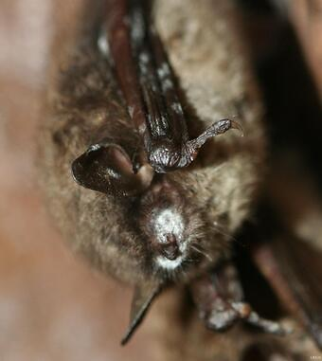  (https://www.usgs.gov/centers/nwhc/science/white-nose-syndrome-vaccine-updates)

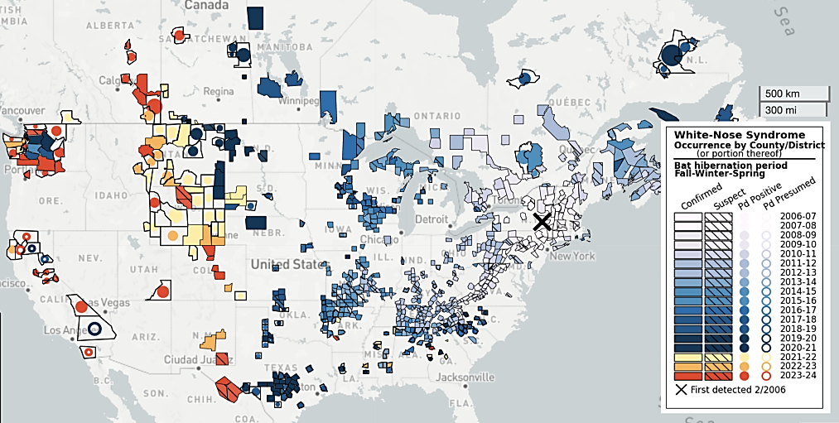
An unshaded county does not indicate bats within the county aren’t impacted by WNS. Instead, the absence of symbols indicates that the Pd (Pseudogymnoascus destructans) fungus that causes white-nose syndrome hasn’t been detected within that county (likely because the county lacks subterranean sites, such as caves or abandoned mines, in which the fungus thrives. (https://www.batcon.org/our-work/research-and-scalable-solutions/white-nose-syndrome/)

The Pd fungus only grows at cold temperatures in the range of 0-20°C. This means that it can only grow in hibernating bats during the winter. During hibernation, body temperature falls from 35-38°C (the temperature of active bats) to below 20°C. In the spring and summer, as bats emerge from hibernation, temperatures rise and immune function increases, causing the amount of Pd to fall to nearly 0. If you want to incorporate this information in the more complete Student Handout, you can insert the Appendix after question 7 of the more complete Student Handout.

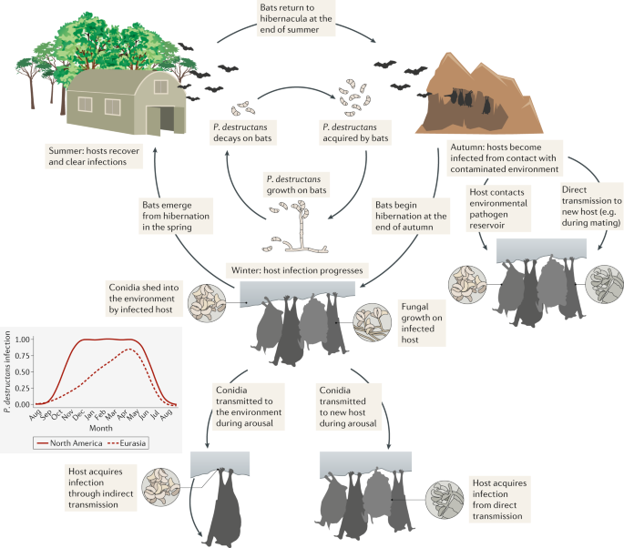
(conidia = spores; https://media.springernature.com/lw685/springer-static/image/art%3A10.1038%2Fs41579-020-00493-5/MediaObjects/41579_2020_493_Fig2_HTML.png)

The cells of Pd, like other fungi, secrete enzymes that break down organic molecules. This releases soluble molecules that can be used by the Pd fungus. As discussed in question 1 (1), fungi that break down dead organic matter play a useful role in nutrient cycling.

The Pd fungus harms bats and can kill them by physiological disruptions that lead to repeated arousals during hibernation, so the hibernating bats run out of their fat stores before food becomes available in the spring (see figure below).
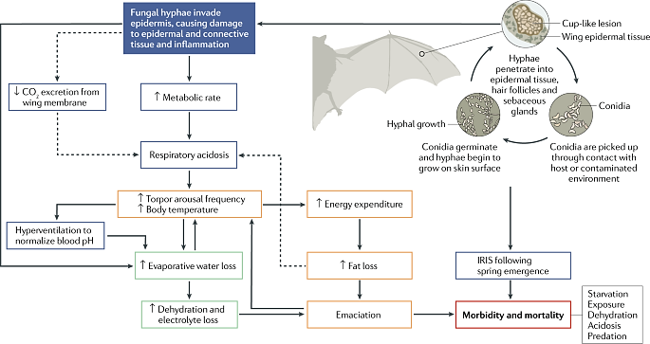
(Dashed arrows = hypothetical relationships; IRIS = immune reconstitution inflammatory syndrome; https://media.springernature.com/lw685/springer-static/image/art%3A10.1038%2Fs41579-020-00493-5/MediaObjects/41579_2020_493_Fig3_HTML.png)

White-nose syndrome has resulted in >90% mortality for some hibernating bat species. It will take a long time for these populations to recover since bats typically give birth to one pup per year.

When bats have been decimated by white-nose syndrome, farmers have responded to the increase in insects by increasing their use of insecticides. These insecticides are spread to humans by water and wind. The increased in utero exposure to insecticides resulted in an ~8% increase in infant mortality. This increased infant mortality was due to internal causes, not accidents or homicides (https://www.science.org/doi/10.1126/science.adg0344).

The 14-minute video, “Stopping White-Nose Syndrome: Can We Save Bats in North America?” (https://www.youtube.com/watch?v=GNPeHhpBAnE) reviews some of this information and introduces a promising vaccine as a method to control white-nose syndrome. This video also portrays the social nature of much research.

If you are using the more complete version of the Student Handout, I recommend that you use the optional question to counteract the negative emotions that may arise from the two examples of human behaviors that resulted in increased human mortality. The article (https://www.fws.gov/story/preventing-and-treating-white-nose-syndrome) describes multiple prevention and treatment strategies and some pros and cons of each strategy. The question asks about scalability, which is as important as efficacy in combating white-nose syndrome.

You may also want to conclude this activity with a discussion of the following challenge. The Pd fungus has not yet spread to the Southern Hemisphere. Some bats in the Southern Hemisphere hibernate and would probably be vulnerable to the Pd fungus. You can ask your students to suggest strategies for preventing the spread of the Pd fungus to the Southern Hemisphere. Among the strategies suggested are identification of probable areas of concern, initiating biosecurity actions that will minimize the risk of introducing the Pd fungus in these areas, and monitoring these areas for Pd fungus (https://conbio.onlinelibrary.wiley.com/doi/full/10.1111/cobi.14390).

Additional Resources
For related activities, see “Ecology Concepts and Learning Activities” (https://serendipstudio.org/exchange/bioactivities/ecology).

Sources of figures in the more complete Student Handout
- Figure on page 1 from https://www.carolina.com/images/teacher-resources/infographics/ecoservices.jpg
- Figure on the top of page 2: https://www.todayifoundout.com/wp-content/uploads/2014/10/Vulture.jpg
- Figures toward the middle of page 2: https://www.indiatoday.in/india/story/patient-bitten-by-rat-telangana-hospital-doctors-suspended-1932295-2022-04-01 and https://news.sky.com/story/six-children-killed-by-packs-of-feral-dogs-in-sitapur-india-11362736
- Figure on page 3: adapted from https://www.howtosmile.org/resource/bat-echolocation
- Figure on page 4: http://pestwildlife.com/bateatsbug.html

Appendix (for possible insertion after the video, “Stopping White-Nose Syndrome: Can We Save Bats in North America?” (near the bottom of page 4 of the more complete Student Handout))

The Pd fungus only grows in cold temperatures. During the winter, some bats hibernate while insects are not flying. The temperatures of hibernating bats drop close to environmental temperatures. Therefore, the Pd fungus can grow in hibernating bats. The figure below shows that the amount of Pd fungus decreases in the spring and summer, when bats are active.
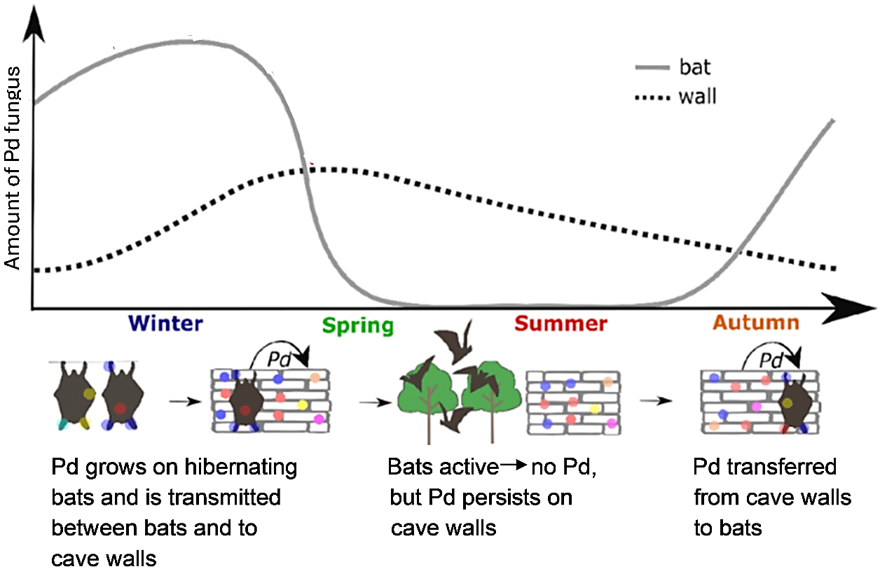

8. Explain the annual cycle of growth of the Pd fungus in bats that hibernate.

9. The Pd fungus only grows in hibernating bats and not bats that migrate to warmer climates during the winter. Explain why.

(Figure adapted from: https://onlinelibrary.wiley.com/doi/10.1111/mec.16249)

By Dr. Ingrid Waldron, Biology Department, University of Pennsylvania, © 2026. These Teacher Notes, two versions of the related Student Handout, and a PowerPoint are available at https://serendipstudio.org/exchange/bioactivities/ecologicaldisturbance.
Quotations from http://www.nextgenscience.org/sites/default/files/HS%20LS%20topics%20combined%206.13.13.pdf and https://www.nextgenscience.org/sites/default/files/Appendix%20G%20-%20Crosscutting%20Concepts%20FINAL%20edited%204.10.13.pdf
Fungal infections in humans include athlete’s foot and ringworm.
Some fungi are symbiotic with plants (https://en.wikipedia.org/wiki/Fungus).

